ACNCG Meeting - Applications of Interest – 10 November 2016
PA1123708 Innova Soil Remediation Facility Link to permit, endorsed plans and VCAT decision
Background

In September 2015 EnviroPacific wrote to Council indicating that they are intending to take over the running of the soil remediation facility at the Dow site. EnviroPacific indicated that they were intending to incorporate a number of improvements into the operation of the site the most notable of which is that all soil handling will be conducted inside a build, including: receiving; processing; and despatching.

In February 2016, plans were endorsed formalising those changes.

Update
The EnviroPacific Soil remediation facility is currently under construction.
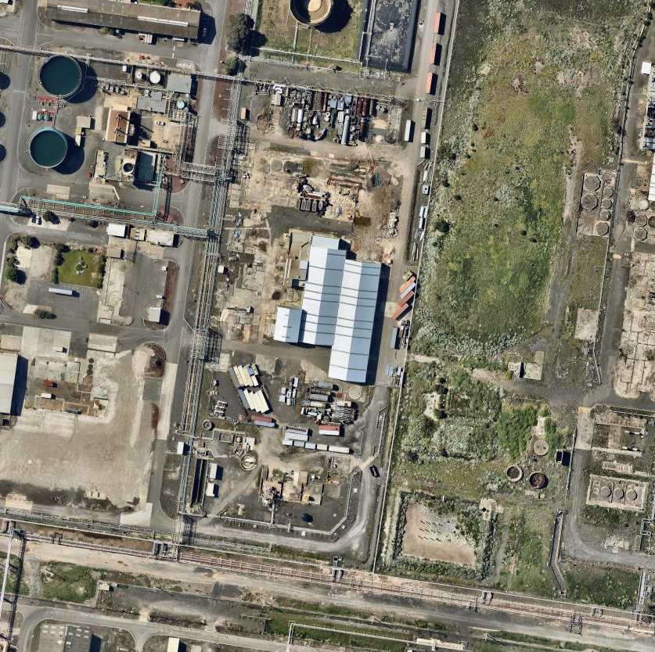
Photograph Date: 8 October 2016

Burns Road Estate - Unserviced Industrial Subdivision Link to Information on Council Website

Background

The series of small land owner meetings is continuing. Approximately 60 owners have attended to date. They represent approximately 40 percent of lots in the estate. The meetings have been welcomed by land owners with most keen to participate in Council’s land owner engagement process.

The small meetings have provided opportunity for owners to meet and explore common concerns in an environment less intimidating than a large group meeting. Attendance is by invitation only and numbers are kept deliberately low to ensure that everybody has an opportunity to be heard. Meetings have been held in Laverton as well as in the eastern suburbs to provide greater convenience for land owners.

At its 9 September 2014 Ordinary Council Meeting, Council resolved to provide funding for a facilitator for a minimum period of one year to work with landowners to build their understanding and facilitate an agreed approach to address the development potential and constraints of the Burns Road Industrial Estate.

Council has since appointed Gerard Coutts and Associates to facilitate the landowner engagement process. At its Ordinary Council meeting on 22 September 2015, Council resolved to extend the facilitation process for a further 18 months for the purpose of electing a land owner group to facilitate a mutually agreed outcome that can satisfy planning and environmental constraints. Nominations from eligible land owners for the Steering Committee closed on 24 March 2016 and are currently being considered.

Update

The Steering Committee has now been formed and is meeting on a regular basis.

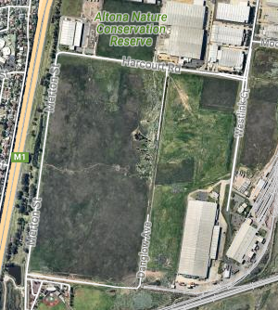

PA1429574 – 650-662 Kororoit Creek Road Service Station - North West Corner of Grieve Parade- Link to Permit

Background

PA1429574- 650-662 Kororoit Creek Rd Altona North VIC 3025 (corner of Kororoit Creek Road and Grieve Parade).
Use and development of the land for the purpose of a service station catering for cars and trucks, convenience shop and food and drink premises; creation of access to a road in a Road Zone 1. The area of the site is 7367m2. The permit was issued 25 November 2014.

July 2015: At this stage the Council does not have any record of a building permit having been issued for the service station, so this project is likely to be some time away from completion.

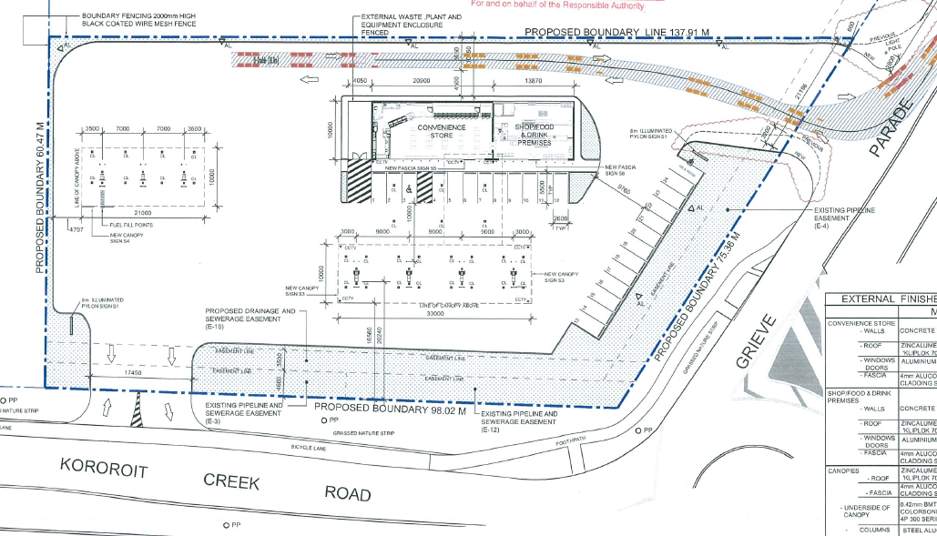

Update

Development plans were endorsed on 14 September 2016.
The permit was issued on 25 November 2014 and is due to expire on 25 November 2016 if the development has not started. The permit holder has a 6 month period after the expiry date within which to extend the permit.

PA1634031 - 300-302 Kororoit Creek Road Service Station - North East Corner of Grieve Parade-
Link to Application

Background

An application has been received for use and development of the land at the north east corner of Kororoit Creek Road and Grieve Parade for the purpose of a service station (Coles Express), advertising signage and new access off a Road Zone Category 1. The site was previously earmarked for a fire station. The application was referred to VicRoads and Melbourne Water.

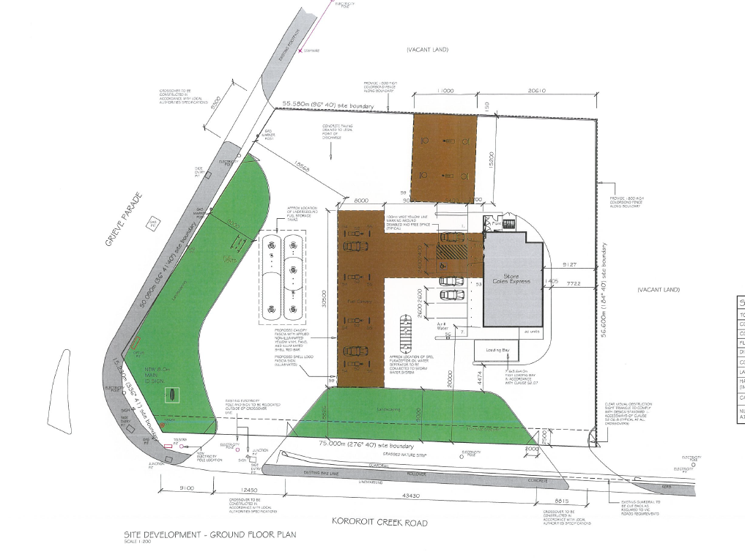

Update

The town planning permit for this development was issued on 31 October 2016. The permit required the submission of amended development plans before the development can be commenced. Those plans are yet to be received.

PA1429152 - 33 Jordan Close, Altona VIC 3018 – Eastern End of Jordon Close Link to Permit

Background

Construction of two building comprising three large warehouses (Building A: 1.4ha +1.7ha and Building B: 2.7ha) and associated offices. Permit issued 6 November 2014. Native vegetation removal authorised under permit PA1021725 which was issued at the direction of VCAT on 2 April, 2013.

The applicant’s representatives have been actively working on the native issue in conjunction with DELWP and Council. The resolution of the native vegetation issue was made a prerequisite of permit PA1429152. The plans is to combine the two native vegetation reserves that are locate half way along Jordon Close with the native vegetation reserve that runs along the railway line. The combined reserves would then be maintained by the Council.

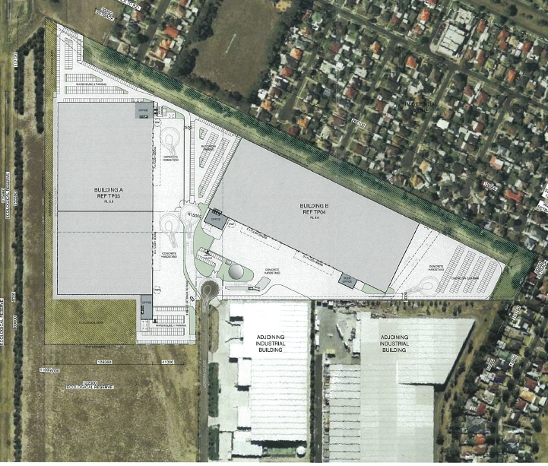

Update

The permit relating to the native vegetation removal has been extended and is due to expire on 2 April 2017. The native vegetation issue and the endorsed plans under the town planning permit need to be addressed before the development can proceed. The town planning permit for the warehouse development expired on 6 November 2016, as the development is yet to commence. The permit can still be extended if an extension request is received within 6 months of the expiry date.

PA1532265 - 210-238 Maidstone St, Altona (Eastern side of Maidstone Street Between the Railway line and Jordon Close) Link to Application Documents

Background

This application is for buildings and works - 10 warehouses, each approximately 420m2 in area and creation of access to a road zone. The overall area of the site is 10,369 m2 and 85 onsite car parking spaces are provided.

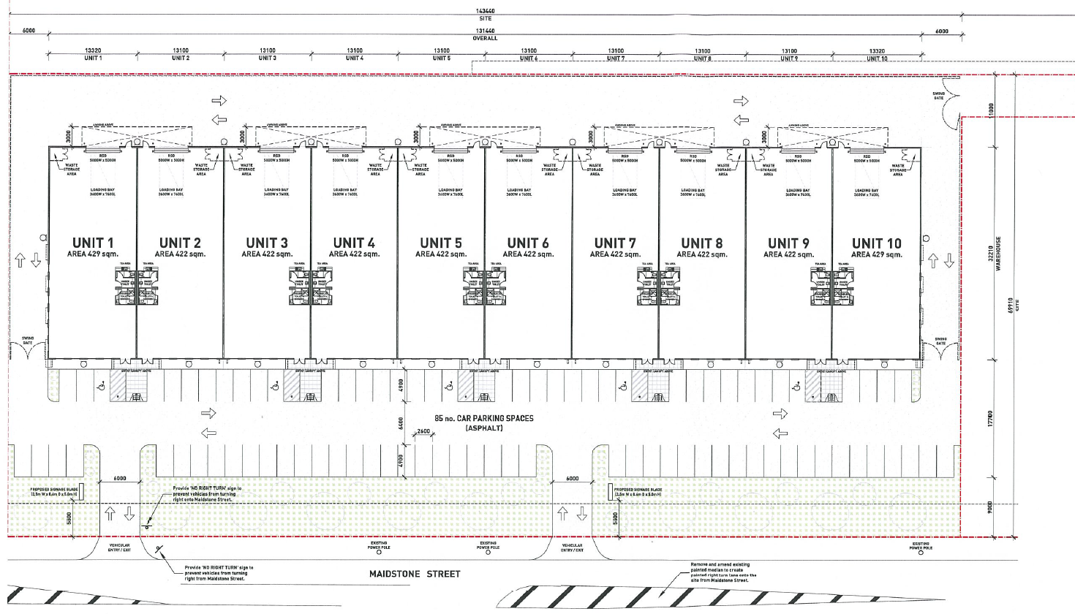

Update

Town planning permit issued 10 July 2016. Development plans are yet to be endorsed.

PA1531738 7 Lot Subdivision of land on the north east corner of Maidstone Street and Jordan Close Link to Permit Documents

Background

An application has been made for a 7 lot subdivision of the land at the corner of Maidstone Street and Jordan Close Altona. The overall area of the land is 6.62 hectares and lot sizes range in six from 2,515m2 to 2.55 hectares. The average lost size is 6,872m2.

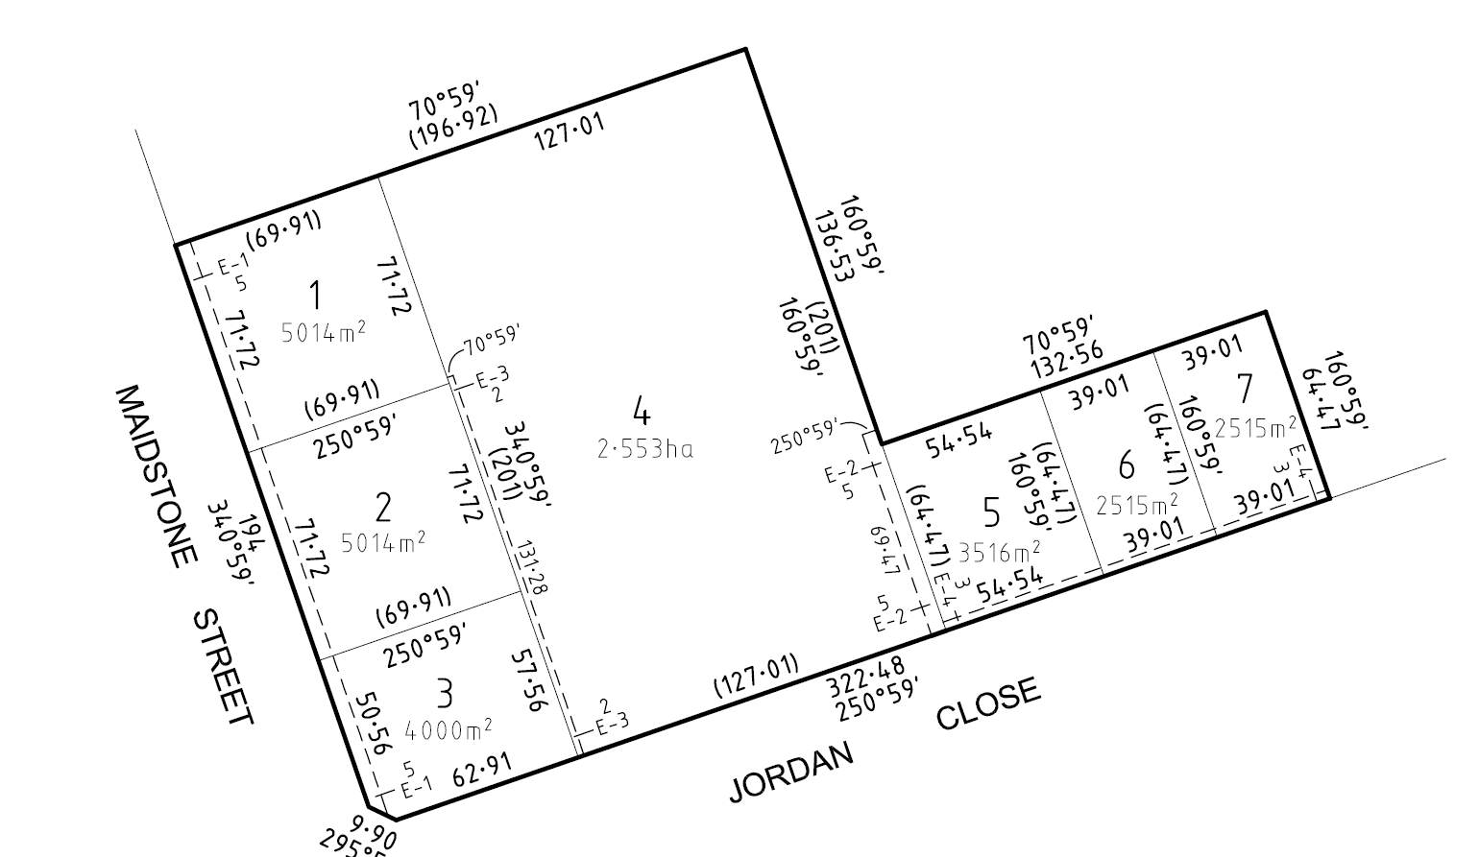

Update

The town planning permit for the subdivision was issued on 16 May 2016. Site works associated with this subdivision are currently underway.

PA1430329 Slough Estate subdivision –Link to Application

Background

An application to subdivide of the balance of the Slough Estate into 58 lots, remove an easement and remove native vegetation was lodged in November 2014. The total land area is 76.78ha, comprising 58 lots (44.7ha), 21 36ha conservation zone, 7.06 ha roads and a “balance lot” adjacent to the existing subdivided land of 3.66 ha.

This application was the subject of a VCAT practice day hearing (preliminary hearing) which found that an Aboriginal Cultural Heritage Management Plan (CHMP) was required prior to the planning permit application for subdivision could be considered. The subdivision was subsequently struck out as misconceived and costs were awarded against the applicant. The VCAT process had been brought on by an appeal against failure to determine, lodged by the applicant.

The applicant is now is now proposing to do a “super lot” subdivision which would see the land progressively subdivided in stages and the lots sizes tailored to meet the needs of the end users of the land.

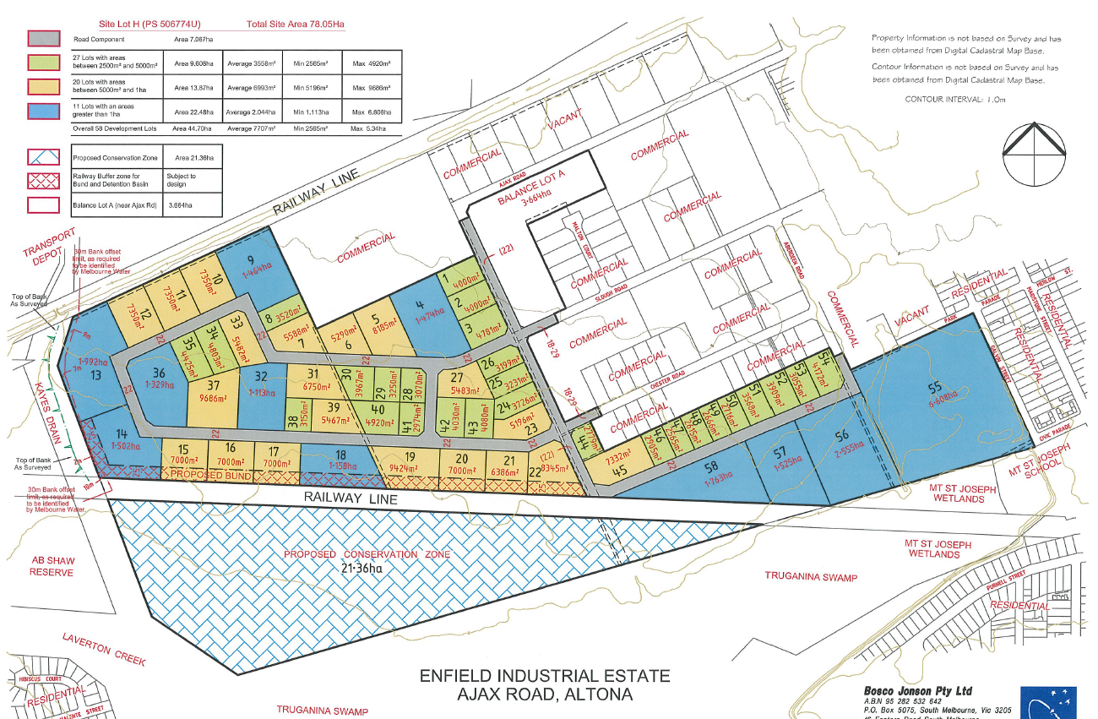

Update

A new application is imminent but not yet received.

PA1430413 –Warehouse - 740 Kororoit Creek Road. – North East Corner Horsburgh Drive and Kororoit Creek Road. Link to Permit
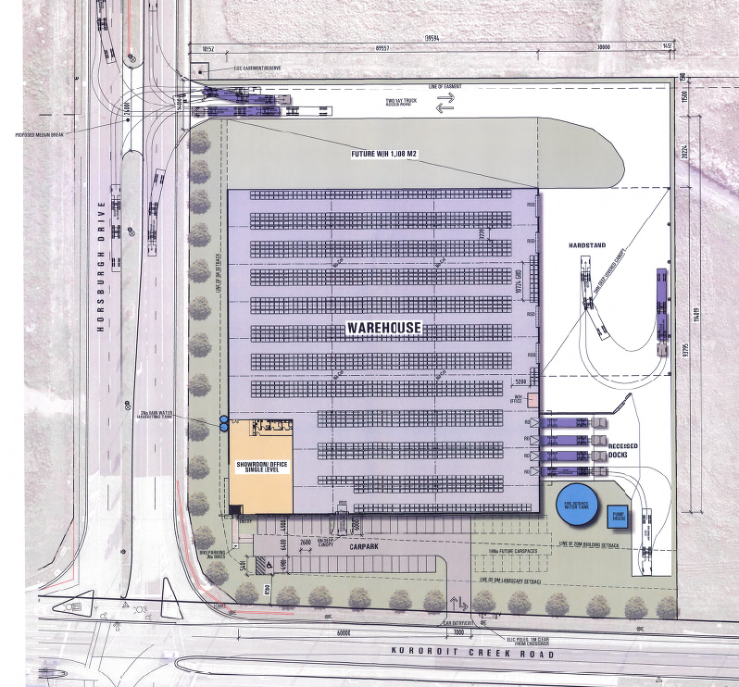
Background

Construction of a warehouse 8399m2 and creation of access to a road in a Road Zone 1. 40 car parking spaces are provided with access from Kororoit Creek Road. The town planning permit was issued 29 April 2015.

Update

The permit was issued on 29 April 2015 and is due to expire on 29 April 2017. No development plans have yet been endorsed.

PA1531807 - 31-33 Horsburgh Dr Altona North VIC 3025 (Eastern side approximately half way between Kororoit Creek Road and the northern end of Horsburgh Drive)
Link to Permit

Background
Buildings and works for the purpose of a warehouse. Floor area 25,000m2.
The town planning permit issued 9 February 2016.

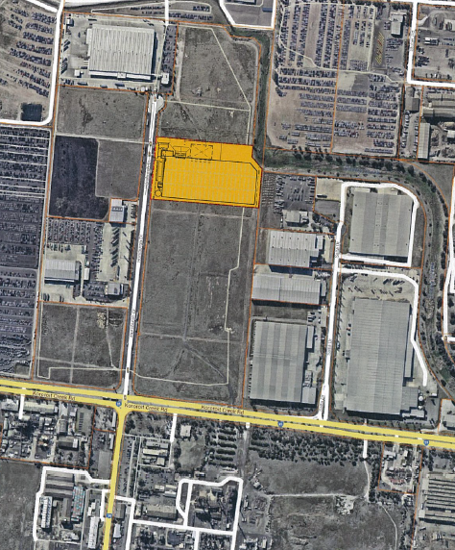

Update

The town planning permit is due to expire on 9 February 2018 if the development has not commenced. Amended town planning drawings required by the permit have not yet been submitted. A building permit cannot be issued until this step has been undertaken.

PA1531809 39-53 Horsburgh Dr Altona North VIC 3025 (Northern end of Horsburgh Drive)
Link to permit
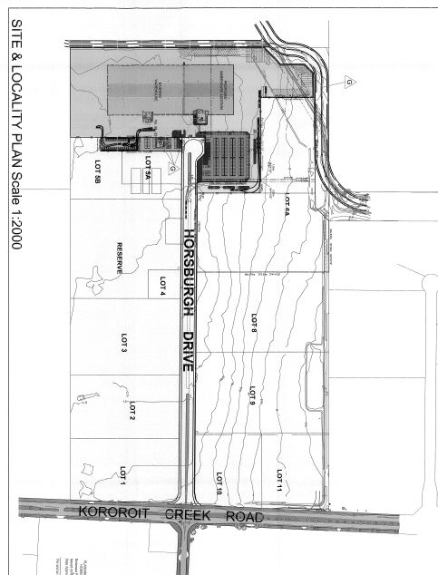

Background

Construction of an extension to the existing warehouse with additional offices, car parking and a reduction in the statutory car parking rate. Area of extension 10,743m2. Application lodged 29 June 2015. Permit issued 2 March 2016

Update

Development plans were endorsed on 27 May 2016. The development currently underway.

PA1531897 - 800-808 Kororoit Creek Rd Altona North (North west corner of Kororoit creek Road and Horsburgh Dr) Link to Application

Background

This application relates to a mixed use development comprising a services station, convenience shop convenience restaurants, restricted retail outlet, service industry and access to a main road. The site has an area of 2.45 hectares. The service station will accommodate both cars and trucks. The site will accommodate four fast food outlets with shared seating. Both will have drive through facilities. The restricted retail element will comprise three automotive related tenancies. The service industry will accommodate motor repairs including truck repairs. 134 car parking spaces will be provided on site.

The permit was issued on 4 March 2016.
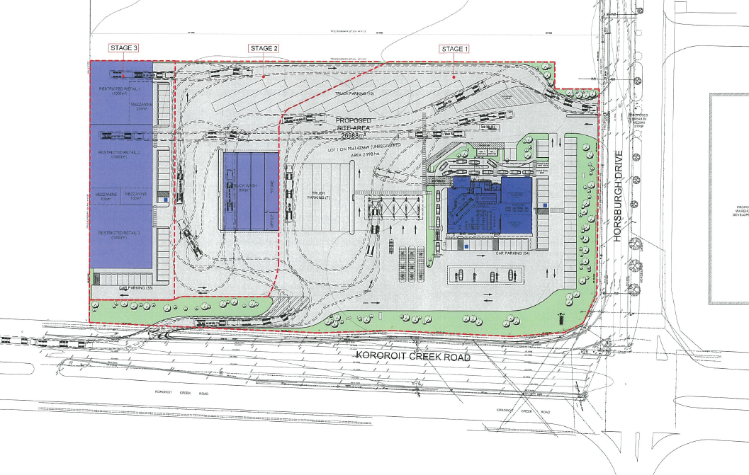
Update
Amended town planning drawings required by the permit were submitted for consideration on 28 October 2016.

PA1635339, 18 Slough Rd, Altona - Education Centre.

New application

An application has been made to use existing premise at 18 Slough Road Altona as an employment and training centre accommodating a maximum of 30 students at any one time. The site is highlighted in yellow below. The application was lodged on 18 October, 2016 and is still under consideration. Further information has been sought from the applicant and that information was submitted on 9 November 2016.
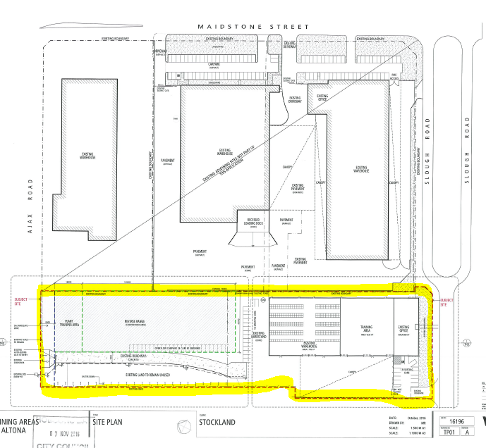

Other Permits of Interest

PA1224258 – 12 lot subdivision of land at 650 - 662 Kororoit Creek Road, Altona North and creation of a road (Citiwest Court) in accordance with the endorsed plans Link to Application
Permit issued September 2012 - subdivision currently being developed.

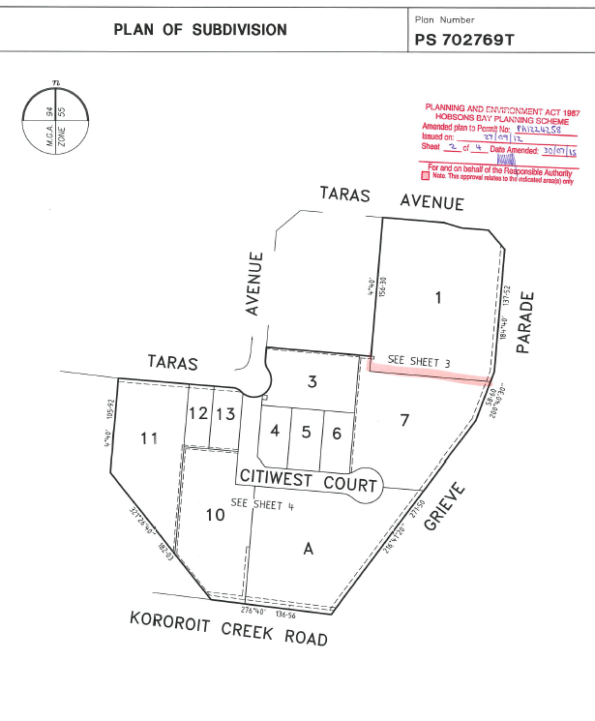

PA0714427 42-60 Modal Pl Altona Use and development of the land for Inland Port, including warehousing, the storage of shipping containers and the removal of native vegetation in accordance with the endorsed plans. Link to Permit Documents

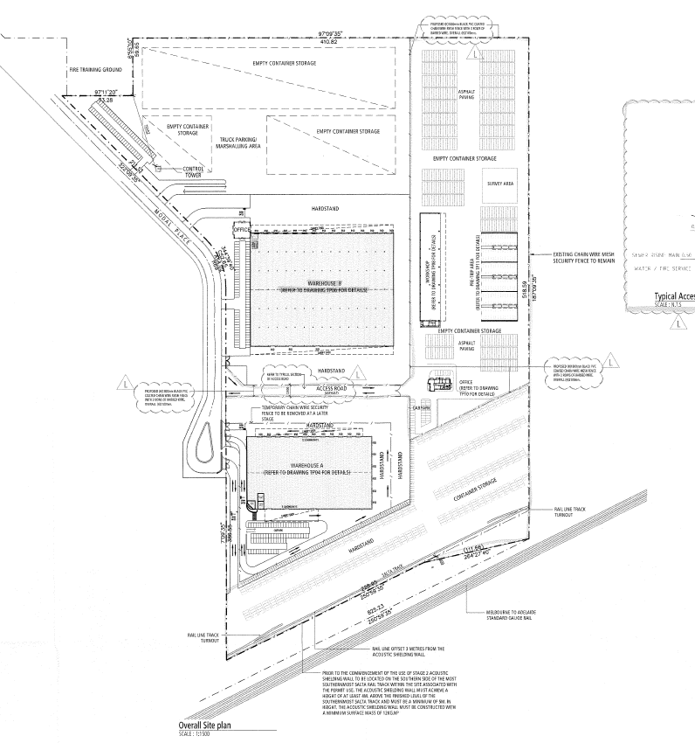

PA0714183 102-120 Modal Pl Altona VIC 3018 Use and development of the land for the purposes of a Freight Distribution Centre (including warehousing)/ Transport Terminal, reduction in the standard parking rate for the above uses, removal of native vegetation. Link to Permit Documents

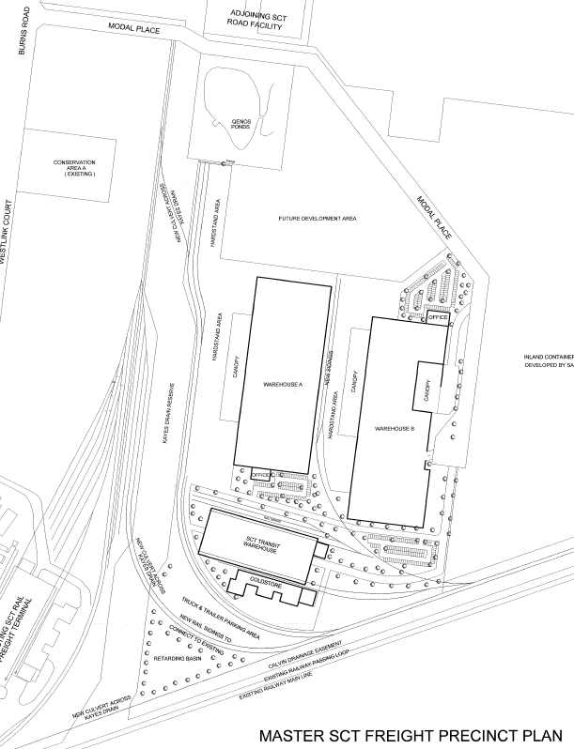

PA1429246 102-120 Modal Pl Altona VIC 3018 Earthworks (filling with clean fill and levelling) outside the floodplain and LSIO affected area in accordance with the endorsed plans.
Link to Permit Documents

