ACNCG Meeting - Applications of Interest – 14 April 2016

Innova - Link to permit and VCAT decision

The town planning permit issued for the contaminated soil remediation facility on the Dow site was due to expire on 1 May 2015. The relevant permit condition, setting out the time limit to start the development, also allows for requests to extend the permit to be made to the Responsible Authority.

Innova submitted a request to extend the permit within the timeframe contained in the condition and the permit has now been extended for a period of 12 months. The permit will now expire if the development does not commence by 1 May 2016 and is not completed by 1 May 2018. The decision to extend the permit was based on an assessment of the following considerations that have been established by various VCAT decisions:-

- Whether there has been a change of planning policy.
- Whether the landowner is seeking to ‘warehouse’ the permit.
- Any intervening circumstances which bear upon grant or refusal of the extension request.
- The lapse of time between the permit and the request.
- Whether the time limit imposed was adequate.
- The economic burden on the landowner by the permit.
- The probability of a permit issuing should a fresh application be made.

Update
In September 2015 EnviroPacific wrote to Council indicating that they are intending to take over the running of the soil remediation facility at the Dow site. EnviroPacific indicated that they were intending to incorporate a number of improvements into the operation of the site the most notable of which is that all soil handling will be conducted inside a build, including: receiving; processing; and despatching.

In February 2016, plans were endorsed formalising those changes.

Burns Road Estate - Unserviced Industrial subdivision Link to Information on Council Website

The series of small land owner meetings is continuing. Approximately 60 owners have attended to date. They represent approximately 40 percent of lots in the estate. The meetings have been welcomed by land owners with most keen to participate in Council’s land owner engagement process.

The small meetings have provided opportunity for owners to meet and explore common concerns in an environment less intimidating than a large group meeting. Attendance is by invitation only and numbers are kept deliberately low to ensure that everybody has an opportunity to be heard. Meetings have been held in Laverton as well as in the eastern suburbs to provide greater convenience for land owners.

Update
At its 9 September 2014 Ordinary Council Meeting, Council resolved to provide funding for a facilitator for a minimum period of one year to work with landowners to build their understanding and facilitate an agreed approach to address the development potential and constraints of the Burns Road Industrial Estate.
Council has since appointed Gerard Coutts and Associates to facilitate the landowner engagement process. At its Ordinary Council meeting on 22 September 2015, Council resolved to extend the facilitation process for a further 18 months for the purpose of electing a land owner group to facilitate a mutually agreed outcome that can satisfy planning and environmental constraints. Nominations from eligible land owners for the Steering Committee closed on 24 March 2016 and are currently being considered.

PA1429574 - Kororoit Creek Road Service Station corner of Grieve Parade- Link to Permit

PA1429574- 650-662 Kororoit Creek Rd Altona North VIC 3025 (corner of Kororoit Creek Road and Grieve Parade).
Use and development of the land for the purpose of a service station catering for cars and trucks, convenience shop and food and drink premises; creation of access to a road in a Road Zone 1. The area of the site is 7367m2. The permit was issued 25 November 2014.

July 2015: At this stage the Council does not have any record of a building permit having been issued for the service station, so this project is likely to be some time away from completion.

Update
Still no record of a building permit having been issued.

PA1429152 - 33 Jordan Close, Altona VIC 3018 – Jordan Close Development Link to Permit

Construction of two building comprising three warehouses (Building A: 1.4ha +1.7ha and Building B: 2.7ha) and associated offices. Permit issued 6 November 2014. Native vegetation removal authorised under permit PA1021725 which was issued at the direction of VCAT on 2 April, 2013.

July 2015: At this stage the Council does not have any record of a building permit having been issued for the warehouses, so this project is likely to be some time away form completion.

Update
The applicant’s representatives have been actively working on the native issue in conjunction with DELWP and Council. The resolution of the native vegetation issue was made a prerequisite of permit PA1429152. The plans is to combine the two native vegetation reserves that are locate half way along Jordon close with the native vegetation reserve that runs along the railway line. The combined reserves would then be maintained by the Council.
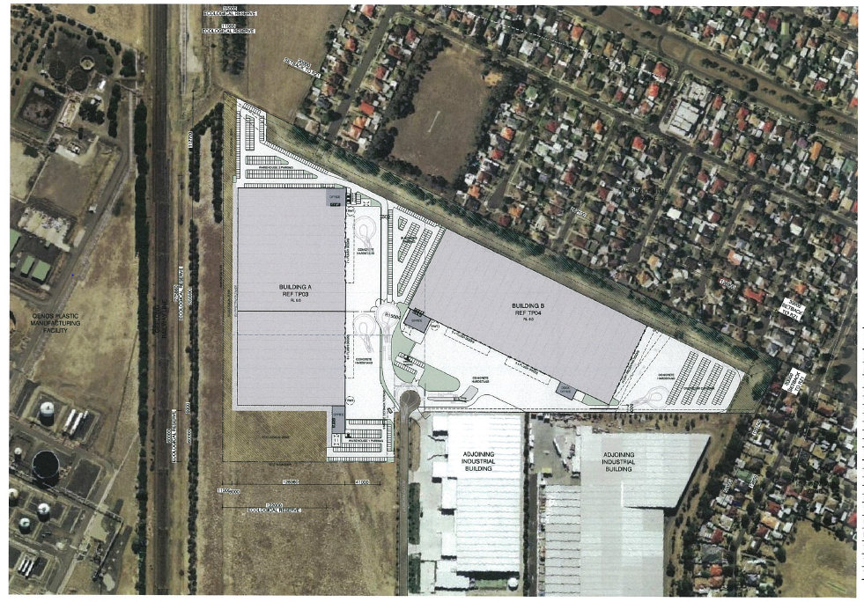

PA1532265 - 210-238 Maidstone St Altona (Eastern side Between the Railway line and Jordon Close)

Buildings and works -10 warehouses 422m2 in area and creation of access to a road zone. The overall area of the site is 10,369 m2 and 85 onsite car parking spaces are provided. A further information request has been sent to the applicant.
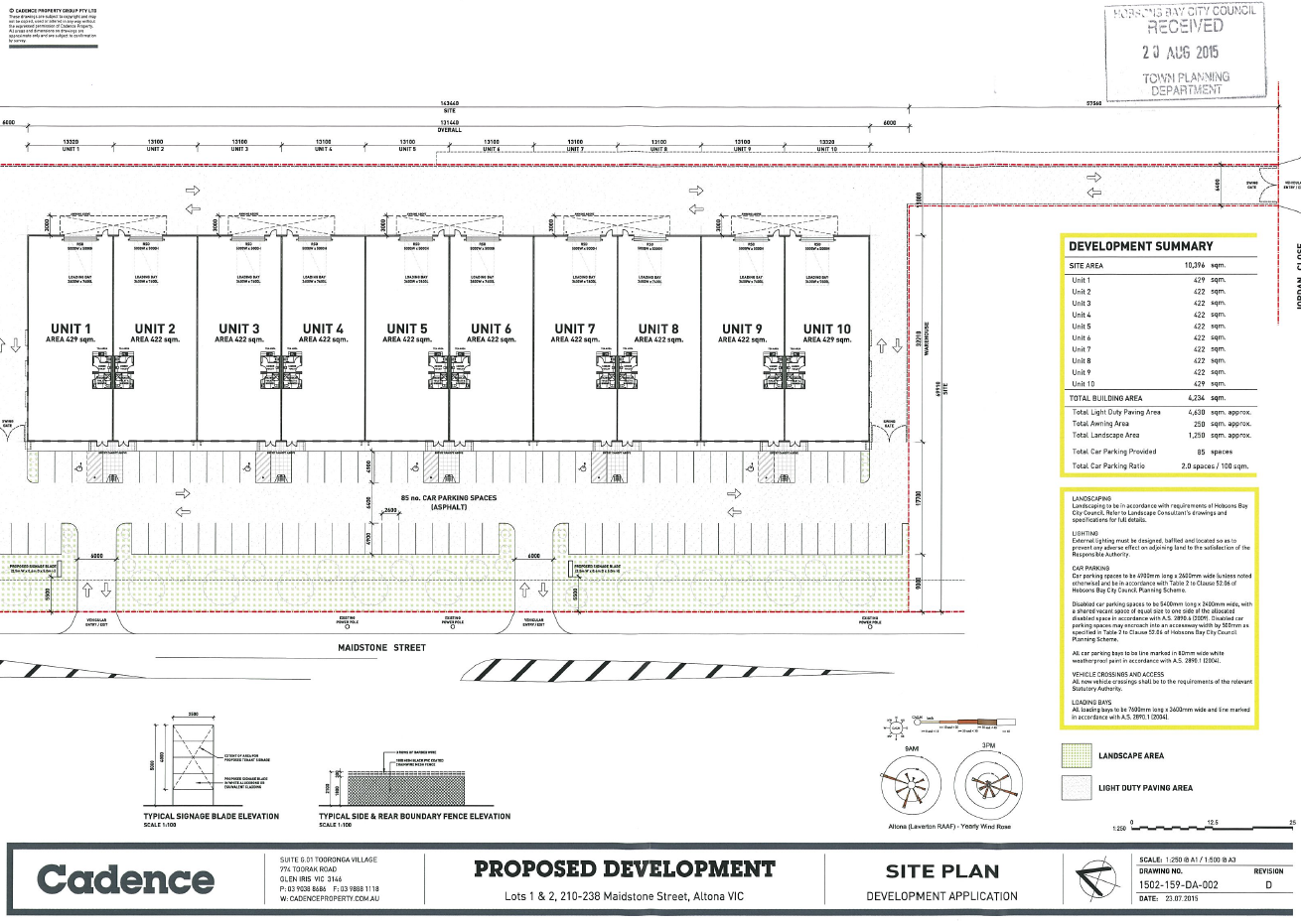

PA1531738 7 Lot Subdivision of land on the north east corner of Maidstone Street and Jordan Close
An application has been made for a 7 lot subdivision of the land at the corner of Maidstone Street and Jordan Close Altona. The overall area of the land is 6.62 hectares and lot sizes range in six from 2,515m2 to 2.55 hectares. The average lost size is 9,457m2.
This application is still being assessed.
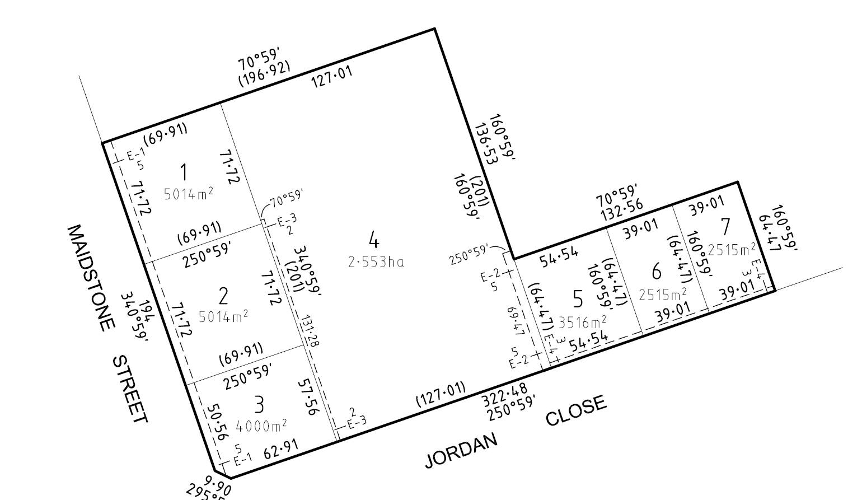

PA1430329 Slough Estate subdivision –Link to Application

Subdivision of the land into 58 lots, removal of easement and removal of native vegetation. The total land area is 76.78ha comprising 58 lots (44.7ha), 21 36ha conservation zone, 7.06 ha roads and a balance lot adjacent to the existing subdivided land of 3.66 ha.

This application was the subject of a VCAT practice day hearing (preliminary hearing) which found that an Aboriginal Cultural Heritage Management Plan (CHMP) was required prior to the planning permit application for subdivision could be considered. The subdivision was subsequently struck out as misconceived and costs were awarded against the applicant. The VCAT process had been brought on by an appeal against failure to determine, lodged by the applicant.

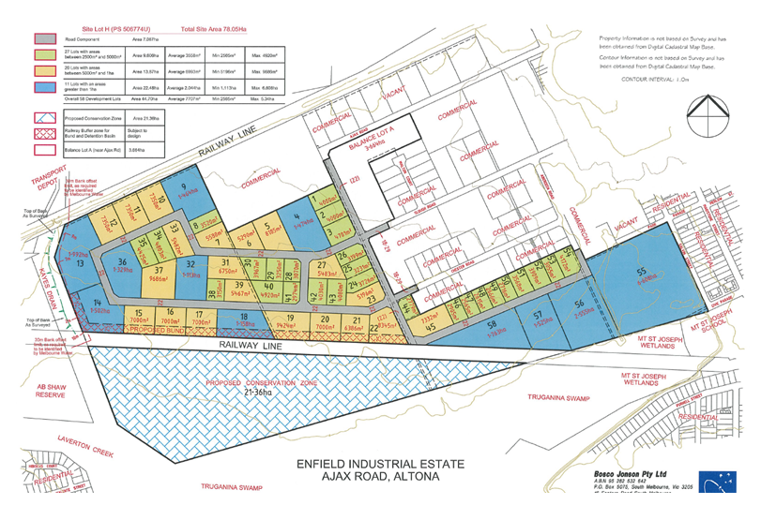

Update
The applicant is now is now proposing to do a “super lot” subdivision which would see the land progressively subdivided in stages and the lots sizes tailored to meet the needs of the end users of the land.

PA1430413 - Warehouse – North East Corner Horsburgh Drive and Kororoit Creek Road. Link to Permit

PA1430413 740 Kororoit Creek Rd Altona North VIC 3025 - Construction of a warehouse 8399m2 and creation of access to a road in a Road Zone 1. 40 car parking spaces are provided with access from Kororoit Creek Road. The town planning permit was issued 29 April 2015.

Update
Still no record of a building permit having been issued.

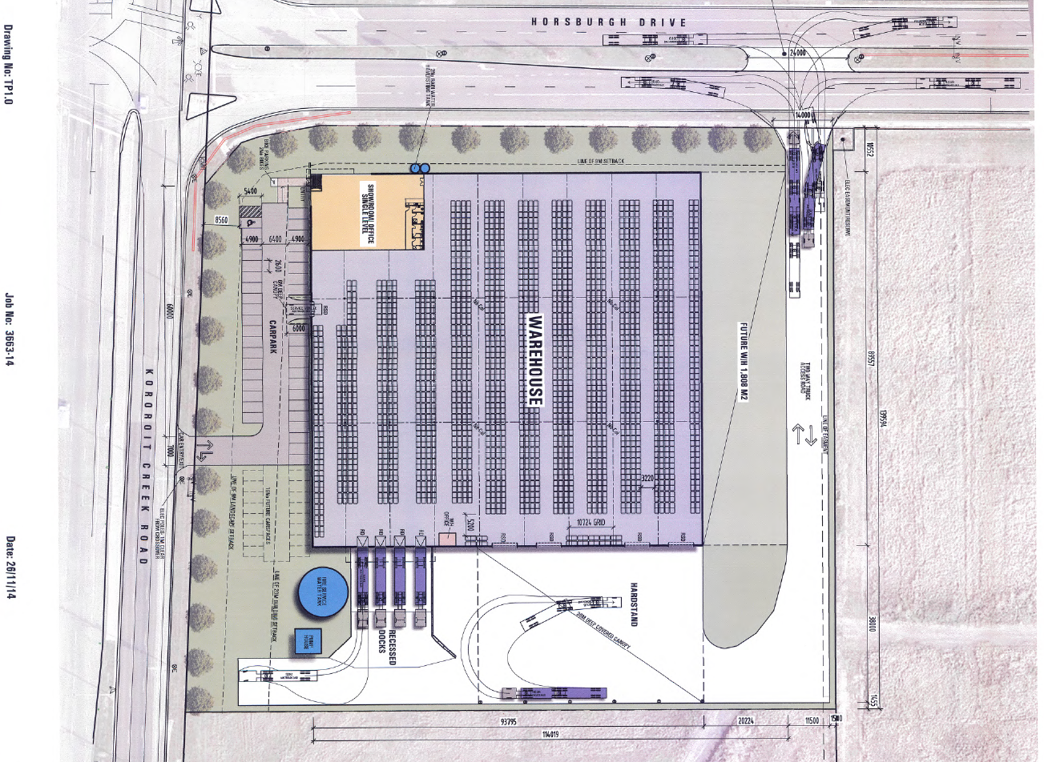

PA1531807 - 31-33 Horsburgh Dr Altona North VIC 3025

Buildings and works for the purpose of a warehouse. Floor area 25,000m2. Lodged 26 June 2015.

Update
Permit issued February 2016.

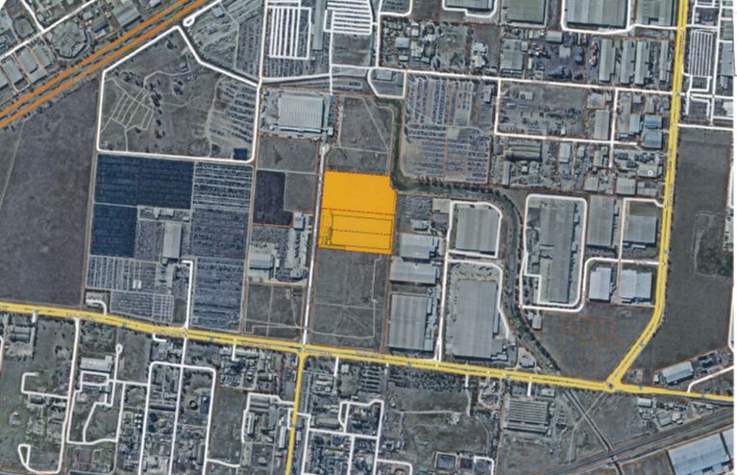

PA1531809 39-53 Horsburgh Dr Altona North VIC 3025

Construction of an extension to the existing warehouse with additional offices, car parking and a reduction in the statutory car parking rate. Area of extension 10,743m2. Application lodged 29 June 2015. .

Update
Permit issued 2 March 29016
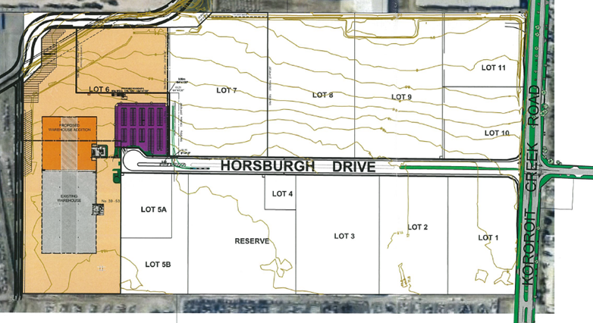

PA1531897 - 800-808 Kororoit Creek Rd Altona North (North west corner of Kororoit creek Road and Horsburgh Dr) Link to Application

This application relates to a mixed use development comprising a services station, convenience shop convenience restaurants, restricted retail outlet, service industry and access to a main road. The site has an area of 2.45 hectares. The service station will accommodate both cars and trucks. The site will accommodate four fast food outlets with shared seating. Both will have drive through facilities. The restricted retail element will comprise three automotive related tenancies. The service industry will accommodate motor repairs including truck repairs. 134 car parking spaces will be provided on site.

The permit was issued on 4 March 2016.
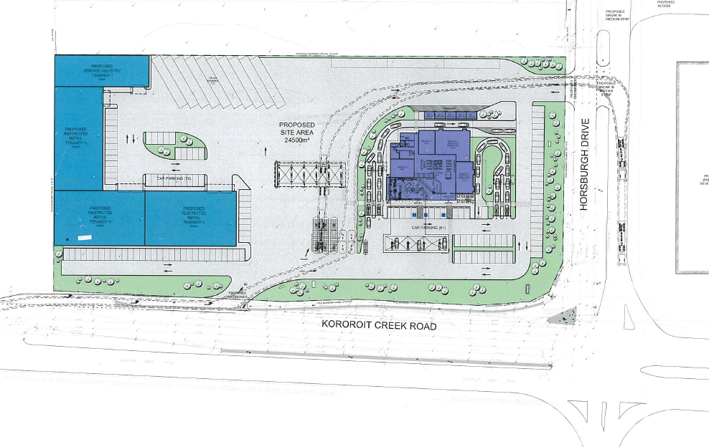

Other Permits of Interest

PA1224258 – 12 lot subdivision of land at 650 - 662 Kororoit Creek Road, Altona North and creation of a road (Citiwest Court) in accordance with the endorsed plans Link to Application
Permit issued September 2012 - subdivision currently being developed.

PA0714427 42-60 Modal Pl Altona Use and development of the land for Inland Port, including warehousing, the storage of shipping containers and the removal of native vegetation in accordance with the endorsed plans. Link to Permit Documents

PA0714183 102-120 Modal Pl Altona VIC 3018 Use and development of the land for the purposes of a Freight Distribution Centre (including warehousing)/ Transport Terminal, reduction in the standard parking rate for the above uses, removal of native vegetation. Link to Permit Documents

PA1429246 102-120 Modal Pl Altona VIC 3018 Earthworks (filling with clean fill and levelling) outside the floodplain and LSIO affected area in accordance with the endorsed plans.
Link to Permit Documents
