ACNCG Meeting - Applications of Interest – 14 July 2016

PA1123708 Innova Soil Remediation Facility
Link to permit, endorsed plans and VCAT decision
Background

In September 2015 EnviroPacific wrote to Council indicating that they are intending to take over the running of the soil remediation facility at the Dow site. EnviroPacific indicated that they were intending to incorporate a number of improvements into the operation of the site the most notable of which is that all soil handling will be conducted inside a build, including: receiving; processing; and despatching.

In February 2016, plans were endorsed formalising those changes.

Update

3D rendition of what the facility will ultimately look like

Burns Road Estate - Unserviced Industrial subdivision Link to Information on Council Website

Background

The series of small land owner meetings is continuing. Approximately 60 owners have attended to date. They represent approximately 40 percent of lots in the estate. The meetings have been welcomed by land owners with most keen to participate in Council’s land owner engagement process.

The small meetings have provided opportunity for owners to meet and explore common concerns in an environment less intimidating than a large group meeting. Attendance is by invitation only and numbers are kept deliberately low to ensure that everybody has an opportunity to be heard. Meetings have been held in Laverton as well as in the eastern suburbs to provide greater convenience for land owners.

At its 9 September 2014 Ordinary Council Meeting, Council resolved to provide funding for a facilitator for a minimum period of one year to work with landowners to build their understanding and facilitate an agreed approach to address the development potential and constraints of the Burns Road Industrial Estate.

Council has since appointed Gerard Coutts and Associates to facilitate the landowner engagement process. At its Ordinary Council meeting on 22 September 2015, Council resolved to extend the facilitation process for a further 18 months for the purpose of electing a land owner group to facilitate a mutually agreed outcome that can satisfy planning and environmental constraints. Nominations from eligible land owners for the Steering Committee closed on 24 March 2016 and are currently being considered.

Update

The Steering Committee has now been formed and is meeting on a regular basis.

PA1429574 – 650-662 Kororoit Creek Road Service Station corner of Grieve Parade- Link to Permit

Background

PA1429574- 650-662 Kororoit Creek Rd Altona North VIC 3025 (corner of Kororoit Creek Road and Grieve Parade).
Use and development of the land for the purpose of a service station catering for cars and trucks, convenience shop and food and drink premises; creation of access to a road in a Road Zone 1. The area of the site is 7367m2. The permit was issued 25 November 2014.

July 2015: At this stage the Council does not have any record of a building permit having been issued for the service station, so this project is likely to be some time away from completion.

Update

The permit applicant has been working on the conditions of the permit that require some action by the applicant prior to the commencement of the development. (e.g. preparation of a landscaping plan).

PA1634031 - 300-302 Kororoit Creek Road Service Station corner of Grieve Parade-
Link to Application

New Application

An application has been received for use and development of the land at the north east corner of Kororoit Creek Road and Grieve Parade for the purpose of a service station (Coles Express), advertising signage and new access off a Road Zone Category 1. The site was previously earmarked for a fire station. The application is currently being assessed including referrals to VicRoads and Melbourne Water.

PA1429152 - 33 Jordan Close, Altona VIC 3018 – Jordan Close Development Link to Permit

Background

Construction of two building comprising three warehouses (Building A: 1.4ha +1.7ha and Building B: 2.7ha) and associated offices. Permit issued 6 November 2014. Native vegetation removal authorised under permit PA1021725 which was issued at the direction of VCAT on 2 April, 2013.

The applicant’s representatives have been actively working on the native issue in conjunction with DELWP and Council. The resolution of the native vegetation issue was made a prerequisite of permit PA1429152. The plans is to combine the two native vegetation reserves that are locate half way along Jordon Close with the native vegetation reserve that runs along the railway line. The combined reserves would then be maintained by the Council.

Update

There are still outstanding town planning permit requirements relating to native vegetation and no town planning plans have yet been endorsed. These issues need to be addressed before a building permit can be issues. The town planning permit is due to expire in November 2016 unless it is extended.

PA1532265 - 210-238 Maidstone St, Altona (Eastern side Between the Railway line and Jordon Close) Link to Application Documents

Background

This application is for buildings and works - 10 warehouses, each approximately 420m2 in area and creation of access to a road zone. The overall area of the site is 10,369 m2 and 85 onsite car parking spaces are provided.

Update

Assessment has been finalised and a permit will be issued shortly.

PA1531738 7 Lot Subdivision of land on the north east corner of Maidstone Street and Jordan Close Link to Permit Documents

Background

An application has been made for a 7 lot subdivision of the land at the corner of Maidstone Street and Jordan Close Altona. The overall area of the land is 6.62 hectares and lot sizes range in six from 2,515m2 to 2.55 hectares. The average lost size is 9,457m2.

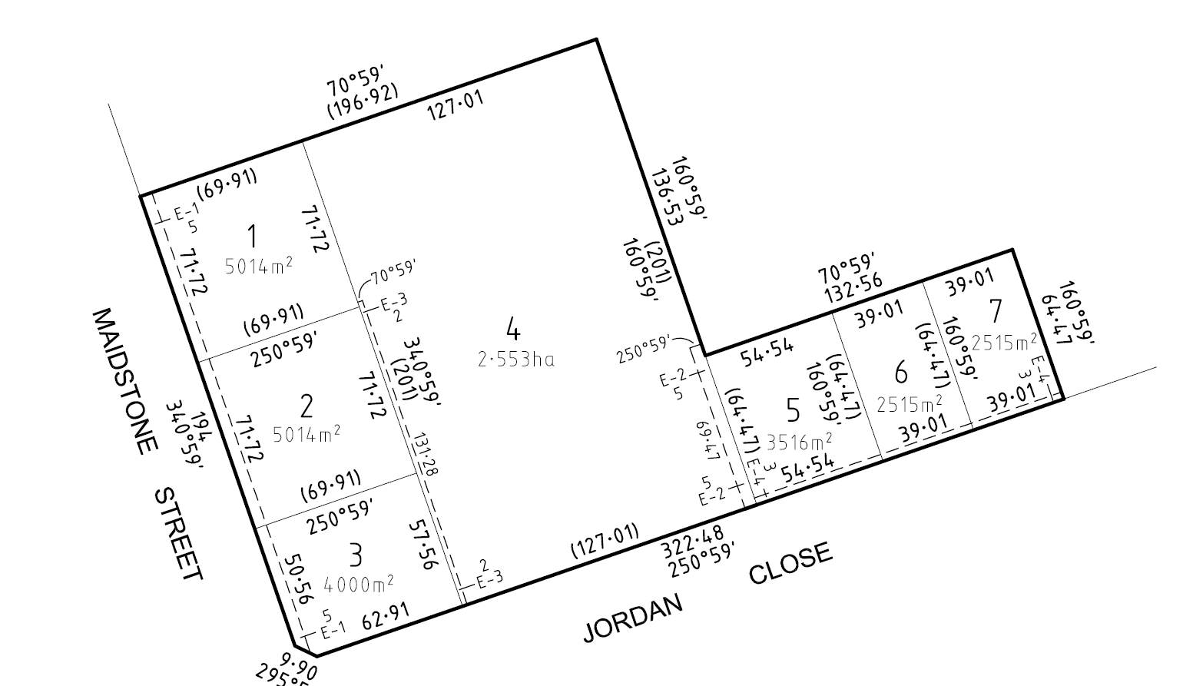

Update

The town planning permit for the subdivision was issued on 16 May 2016.

PA1430329 Slough Estate subdivision –Link to Application

Background

An application to subdivide of the balance of the Slough Estate into 58 lots, remove an easement and remove native vegetation was lodged in November 2014. The total land area is 76.78ha, comprising 58 lots (44.7ha), 21 36ha conservation zone, 7.06 ha roads and a “balance lot” adjacent to the existing subdivided land of 3.66 ha.

This application was the subject of a VCAT practice day hearing (preliminary hearing) which found that an Aboriginal Cultural Heritage Management Plan (CHMP) was required prior to the planning permit application for subdivision could be considered. The subdivision was subsequently struck out as misconceived and costs were awarded against the applicant. The VCAT process had been brought on by an appeal against failure to determine, lodged by the applicant.

The applicant is now is now proposing to do a “super lot” subdivision which would see the land progressively subdivided in stages and the lots sizes tailored to meet the needs of the end users of the land.

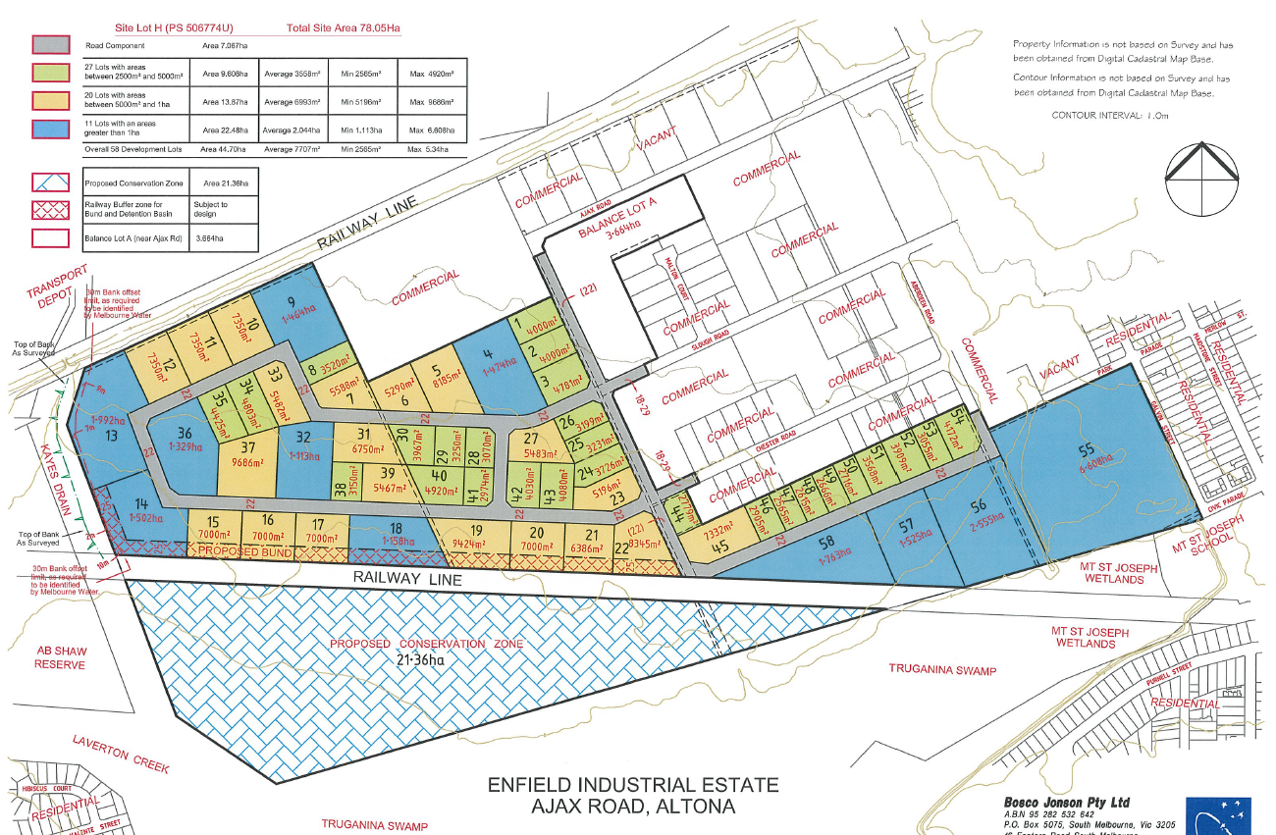

Update

A new application is imminent but not yet received.

Council has made an application to VCAT relating to the non-payment of costs by the applicant to the Council following on from the previous VCAT hearing.

PA1430413 - Warehouse – North East Corner Horsburgh Drive and Kororoit Creek Road.
Link to Permit

Background

Construction of a warehouse 8399m2 and creation of access to a road in a Road Zone 1. 40 car parking spaces are provided with access from Kororoit Creek Road. The town planning permit was issued 29 April 2015.

Update

Amended town planning drawings required by the permit have not yet been submitted. A building permit cannot be issued until this step has been undertaken.

PA1531807 - 31-33 Horsburgh Dr Altona North VIC 3025 (Eastern side approximately half way between Kororoit Creek Road and the northern end of Horsburgh Drive)
Link to Permit

Background
Buildings and works for the purpose of a warehouse. Floor area 25,000m2. Lodged 26 June 2015.
Permit issued February 2016.

Update

Amended town planning drawings required by the permit have not yet been submitted. A building permit cannot be issued until this step has been undertaken.

PA1531809 39-53 Horsburgh Dr Altona North VIC 3025 (Northern end of Horsburgh Drive)
Link to permit

Background

Construction of an extension to the existing warehouse with additional offices, car parking and a reduction in the statutory car parking rate. Area of extension 10,743m2. Application lodged 29 June 2015. Permit issued 2 March 2016

Update

Plans endorsed 27 May 2016.

PA1531897 - 800-808 Kororoit Creek Rd Altona North (North west corner of Kororoit creek Road and Horsburgh Dr) Link to Application

Background

This application relates to a mixed use development comprising a services station, convenience shop convenience restaurants, restricted retail outlet, service industry and access to a main road. The site has an area of 2.45 hectares. The service station will accommodate both cars and trucks. The site will accommodate four fast food outlets with shared seating. Both will have drive through facilities. The restricted retail element will comprise three automotive related tenancies. The service industry will accommodate motor repairs including truck repairs. 134 car parking spaces will be provided on site.

The permit was issued on 4 March 2016.
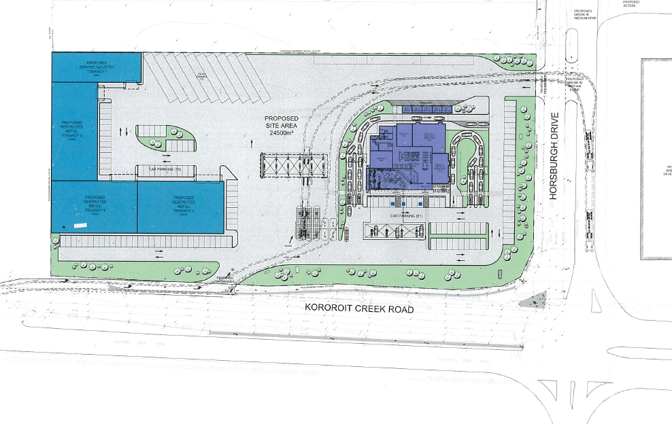
Update
Amended town planning drawings required by the permit have not yet been submitted. A building permit cannot be issued until this step has been undertaken.

Other Permits of Interest

PA1224258 – 12 lot subdivision of land at 650 - 662 Kororoit Creek Road, Altona North and creation of a road (Citiwest Court) in accordance with the endorsed plans Link to Application
Permit issued September 2012 - subdivision currently being developed.

PA0714427 42-60 Modal Pl Altona Use and development of the land for Inland Port, including warehousing, the storage of shipping containers and the removal of native vegetation in accordance with the endorsed plans. Link to Permit Documents

PA0714183 102-120 Modal Pl Altona VIC 3018 Use and development of the land for the purposes of a Freight Distribution Centre (including warehousing)/ Transport Terminal, reduction in the standard parking rate for the above uses, removal of native vegetation. Link to Permit Documents

PA1429246 102-120 Modal Pl Altona VIC 3018 Earthworks (filling with clean fill and levelling) outside the floodplain and LSIO affected area in accordance with the endorsed plans.
Link to Permit Documents

